Exercise #7
- List the names of 5 youngest employees in the company.
SELECT * FROM employee_data ORDER BY age LIMIT 5;
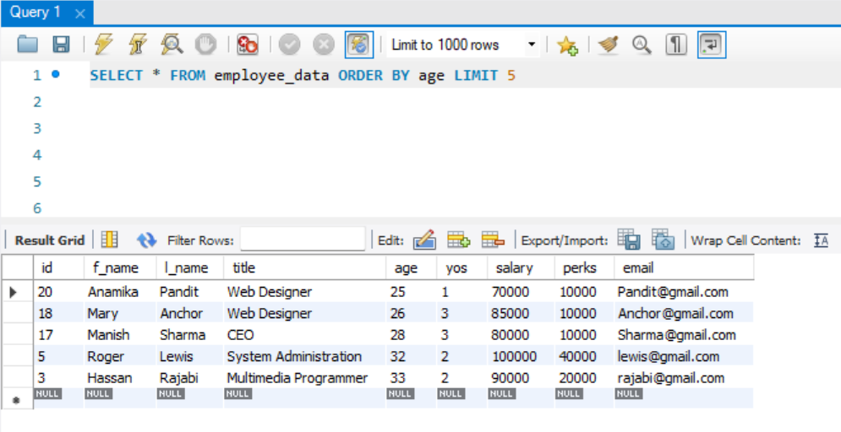
- Extract the next 5 entries starting with the 10 row.
SELECT * FROM employee_data LIMIT 5 OFFSET 9;
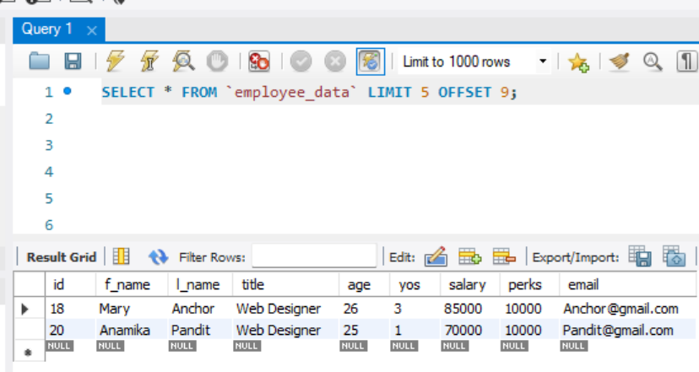
- Display the names and salary of the employees who draws the largest salary.
SELECT f_name, l_name, salary FROM employee_data WHERE salary = (select max(salary) from employee_data);
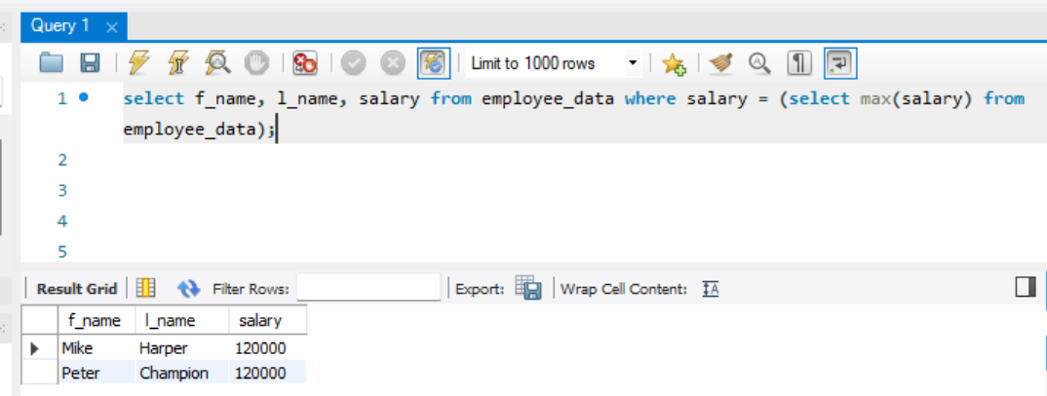

- What does the following statement display?
SELECT emp_id, age, perks from employees_data ORDER By perks DESC LIMIT 10;

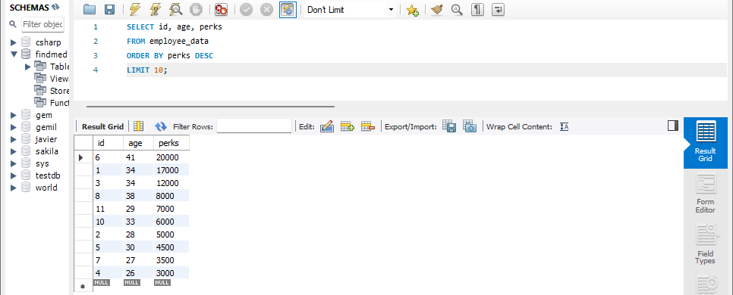
-- Displays 10 rows of id, age and perks of the employees sorted by perks in descending order.

